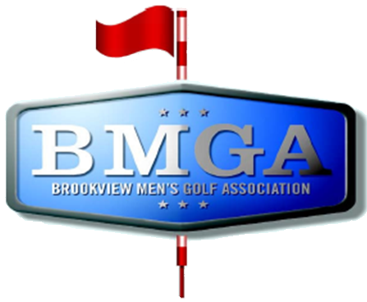
BMGA Board Agenda
Date: June 17, 2026 7:30 PM
Location: Sweeny Lake Conference Room
Next Board Meeting: July 15, 2026 7:30 PM

Attendees:
Attendee: | Present/Absent | Attendee: | Present/Absent
Larry Jocelyn (Y3) | P | Richard Brynteson | A
Paul Yakshe (Y3) | P | Ben Disch (BV) | A
Michael Saless (Y3) | P | Brett Johnson (BV) | A
Phil Berndt (Y2) | P | Andrew Bromander (BV) | A
Brian Beitlich (Y2) | P | Curt Medina | P
Luke Rajkowski (Y2) | P | Corey Smith | P
Eric Beitlich (Y1) | P | Tim Lueder | P
Matt Haws (Y1) | P | Roger Hamm | P
Patrick Hoffman (Y1) | P

AGENDA

- Call to Order
- Approval of May 2026 Board Meeting Minutes
- Brookview Course Update (Ben, Brett, Andrew, Brian)
- Captains were invited to this meeting; we will hear from the captains who attend this meeting.
- Wells Fargo and Venmo Accounts – Paul, Phil, Larry
- Sponsorship Status – Paul and Sponsorship Committee
- Tournament Committee Status – Patrick and Luke
- Published Meeting Minutes? - Eric
- Non-injury resignation from league. Adding a player from the waiting list?

Meeting Notes
Captains:
- Concern about why golf was cancelled for 6/17/2026
- Suggestion to not cancel golf when it’s walking only
- Subs: Update the sub list more, be more communicative about who is actually willing to sub
- Need to advertise the league more – Membership is not deep enough to support the number of injuries we’ve had
- Roger: a discount to join the league half way through
- Do we allow members who aren’t playing to sub for teams that are shorthanded
- Patrick: Wants it to be a more thought-out substitute rule and a possible motion next meeting
- Roger: Handicap adjustment to 85% instead of 100%, course is playing easier, and shorter. Short term problem?
  - Wait for a rerating
  - A possible motion for next year
- Revisit the Triad system
  - Discuss with Richard about a possible solution
  - Add it to the agenda for next year
- Why are the stroke play/match play handicaps different? Rounding issue?
  - Patrick to look into it
Weather:
- Update the cancellation policy or wording, do we need to make it more specific. Do we need to add it into the bylaws?

