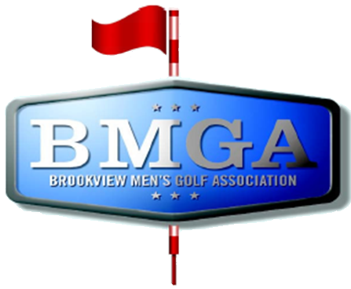
BMGA Board Meetings
Date: March 18, 2026 6:00PM
Location: Sweeny Lake Conference Room
Next Board Meeting: April 15, 2026 6:00 PM

Attendees:
Attendee: | Present/Absent | Attendee: | Present/Absent
Larry Jocelyn (Y3) | Y | Richard Brytenson | Y
Paul Yakshe (Y3) | Y (Virtual) | Ben Disch (BV) | N
Michael Saless (Y3) | Y | Brett Johnson (BV) | N
Phil Berndt (Y2) | Y | Andrew Bromander (BV) | N
Brian Beitlich (Y2) | Y | Dave Bialke (Member) | Y
Luke Rajkowski (Y2) | Y
Eric Beitlich (Y1) | Y
Matt Haws (Y1) | N
Patrick Hoffman (Y1) | Y

AGENDA

- Call to Order
- Approval of February 2026 Board Meeting Minutes
- Dave Bialke – BMGA Expectations
- Wells Fargo and Venmo Accounts – Larry
- Changes to League Guide for 2026
- Kegs – Patrick Hoffman
- Draft – March 25, 2026
- Draft Related – IR/Keeper Can a person on IR be on a captains keeper list the following year? – Eric B
- Sponsorship Status – Paul and Sponsorship Committee
- CTB-Don Grove Draft Protection
- Dylan Niska email
Minutes:
Dave Bialke:
Golden Valley is considering stopping allowing BMGA from purchasing kegs. With further consideration of league cancellation. The city (City Attorney/City Manager) has asked Dave to address the membership at the spring meeting to stress the seriousness which Golden Valley considers our behavior. Harassment issues are front and center. Concerns were raised that the city has continued to broach this issue, with no real path forward. Plan to add time to the meeting to address code of conduct.

Finances:
Checking – 102k
Savings – 5k
Need to transfer $5 per player to the savings per player
Venmo balance is slowly being transferred to checking account, $5k balance transfer

Changes to league guide:
Reviewed the updated changes to the guide as a group.
Eric Motioned to add changes to the league to the guide related to the draft order and returning IR members, the motioned was seconded by Phil. Motion Passed.
Eric to reach out to Bob Boufford regarding Steve Haik

Kegs:
Patrick and Luke reached out Brookview regarding beer selection. They have options throughout the year to get bulk keg purchases with deals. The league will get a better selection. The league should put a beer selection list together of beers that we don’t want.

Draft:
Reviewed the draft spreadsheet. Eric to update the draft. Make table tents for the draft and the spring social. Put them in order. Phil and Eric to run the draft. Pitchers of beer $200-300.

Sponsorship Status:
There was a committee meeting with Matt Haws/Paul Yakshe and others. No minutes from the meeting. Concrete changes made: If someone brings in a weekend sponsor you get one free tournament registration. Matt has secured a Wednesday Night sponsor (potentially). Paul created a flyer to send out. Chichi’s and Boston Scientific are back for $1000. BMW is down to $500. Of the 11 sponsors, 7 have come forward. Paul is optimistic that the remaining will return as well. Mulligans indoor golf has returned.

Scorecards:
Gerry Meier has mentioned he will print the wednesday night league scorecards again this year. Michael Saless has taken the responsibility. Need to get the new PDF to Gerry by April 1st.

Dylan Niska/Women in BMGA:
The board elected to not broach the issue at this meeting.

Tee Box Markers:
Being replaced and we are auctioning them off the old BMGA markers as a silent auction at the spring meeting.

