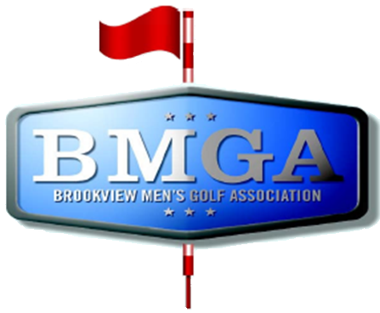
BMGA Board Agenda
Date: May 13, 2026 7:30 PM
Location: Sweeny Lake Conference Room
Next Board Meeting: June 17, 2026 7:30 PM

Attendees:
Attendee: | Present/Absent | Attendee: | Present/Absent
Larry Jocelyn (Y3) | P | Richard Brynteson | P
Paul Yakshe (Y3) | P | Ben Disch (BV) | P
Michael Saless (Y3) | P | Brett Johnson (BV) | P
Phil Berndt (Y2) | P | Andrew Bromander (BV) | A
Brian Beitlich (Y2) | P | Brian Haley (BV) | P
Luke Rajkowski (Y2) | P
Eric Beitlich (Y1) | P
Matt Haws (Y1) | P
Patrick Hoffman (Y1) | P

AGENDA

- Call to Order
- Approval of April 2026 Board Meeting Minutes
- Brookview Course Update (Ben, Brett, Andrew, Brian)
- Brian Haley (Brookview Superintendent)
  - Berm on hole #6
- Wells Fargo and Venmo Accounts – Paul, Phil, Larry
- League Guide wording – Larry
  - Page 3 Brookview Club Membership and USGA Handicap Fee must be purchased at the Brookview Pro Shop.: Purchased at Brookview Golf Course. Roger Hamm pointed out to me that there are several members who’s USGA Handicap Fee was not established at Brookview. (Also on Page 5. Requirements section)
  - Page 10 Gold Tee – Age 65 the day you play, remove birth year eligibility
  - USGA Competitive Fairness Gender Policy
    - USGA Announces New Competitive Fairness Gender Policy
  - Female v Male determine which slope rating to use by person getting the strokes.
- Membership Status – Eric B. Weekend registrations not paid
- Sponsorship Status – Paul and Sponsorship Committee
- Invite captains to a future board meeting

Notes:
Brookview Updates:
- MGA is coming to rerate next year
- 13/7 tee boxes will hopefully be ready by late June/early July
- 8 tee is hopefully early june
- Grant from DNR to replace 62 trees, will try to be smarter to where they plant them. Will start ordering soon (tomorrow)
- Almost 300 trees removed
- Bought two nice rollers that are helping with trueness and speed
- #6 berm will remain a hazard going forward
Finance updates:
- Wells Fargo has adequate cash
- Business account has adequate cash
- Paypal money has been deposited
- Venmo money has been deposited
- MPGA annual payment is 100, usps
- We will pay for metro seniors league fee, $300
- Invoices for the first two weeks: Greek scramble audited and passes
League Guide:
- Gold tees is now worded as a flat 65 requirement
- Eric to remove birth year eligibility and reword to on the “day of play”
- Update bylaws for gender specific slope/rating is assigned per the usga and follows usga rulings
Suggestions/further topics of discussion:
- Replace the match play events with additional events – phil
- Invite captains to next board meeting
- Next year idea to propose not allowing people without a GHIN handicap to register for the league
Membership Status:
- Eric to reach out remaining unpaid weekend
- Dan Peters Sr. is going to be refunded
Sponsorship Status:
- Matt/Northern Tool are switching to stableford for sponsorship
- Has chichi’s paid?
- Golow golf is supposed to sponsor Calcutta, haven’t heard anything?

