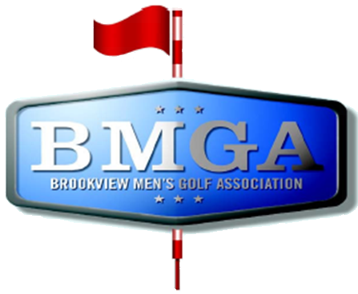
BMGA Board Agenda
Date: August 19, 2026 7:30 PM
Location: Sweeny Lake Conference Room
Next Board Meeting: September 16, 2026 7:30 PM

Attendees:
Attendee: | Present/Absent | Attendee: | Present/Absent
Larry Jocelyn (Y3) | P | Richard Brynteson
Paul Yakshe (Y3) | P | Ben Disch (BV)
Michael Saless (Y3) | A | Brett Johnson (BV)
Phil Berndt (Y2) | P | Andrew Bromander (BV)
Brian Beitlich (Y2) | P
Luke Rajkowski (Y2)
Eric Beitlich (Y1)
Matt Haws (Y1)
Patrick Hoffman (Y1)

AGENDA

- Call to Order
- Approval of July 2026 Board Meeting Minutes
- Wells Fargo and Venmo Accounts – Paul, Phil, Larry (Paul will try to connect via StarLink)
- Sponsorship Status – Schuller’s status? Phil, please check the PO Box for a check from Schuller’ before the meeting - Paul and Sponsorship Committee
- Tournament Committee Status – Patrick and Luke
  - Opening Day weekend event options
Topics for Discussion
- Hole-in-one Flag proposal – Larry
- TrueStone Financial as a potential sponsor in 2027
- 2027 Board
- Fall Finish change to 2 man alternate shot/3 teams each tee
Meeting Minutes:
July Meeting Minutes Approved
Finances:
Finances are looking good, the venmo account has ~600, Colin Reedy incorrectly venomed us.
Move 390 from venmo into the bank account. Leave 150 in the venmo.
Tournament Committee:
Opening day weekend events:
Patrick would like the weekend tournament to be replaced with one that is not a season long event. Prior to the fall meeting would like to have it locked down. Propose that by next meeting we have ideas. Shared doc to be published by Patrick for next board meeting that we can discuss in September’s board meeting. Not getting rid of the Greek scramble. It opens up a sponsorship possibility. Firmer deadlines for the 2 man/single match play Harsher punishments for missing deadlines. Need to firm up language for exigent circumstances. Patrick to publish brackets much earlier to help with scheduling conflicts. Rounds must be completed by X date or head to coinflip. Matt raised concerns it may weed people out for registration. April 1st for handicaps.

Sponsorship
Schullers still hasn’t paid – Update, they have paid

3 person alternate shot
Possibly too late to change it for this year. Next year we should switch it to a 3 team 2 man alternate shot instead of a 3 person alternate shot. Pace of play may be an issue. Motion to switch it to 2 man alternate shot next year, it passes. Motion that luke is in charge of food for this years fall finish. It passes.
Hole in one flag proposal
Dave supalla wanted the flag, brookview charges $50 for the flag. Larry proposes we take the money out of the hole-in-one fund. Richard talks about operationalizing where we get the $50. A proposal to make it a gift from the league. Refund the balance of $50 to the hole in ones. Phil raises a motion to cover the $50 and pay it to the members. Motion passes.

Trustone financial as a sponsor got buried in Larry’s email. We need to reach out to them, Larry to send the email to the board and we will reach out.
2027 board:
Question for Richard. Do we just send an email out to the membership about it? Larry Paul and Mike are leaving. Eric to create the forms for the election. Nominees by October 1st. GHIN for proving voting.
Instagram:
Matt to create it

