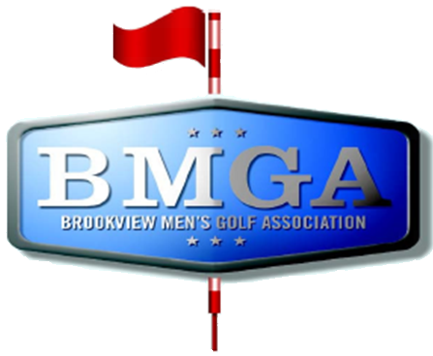
BMGA Board Agenda
Date: July 15, 2026 7:30 PM
Location: Sweeny Lake Conference Room
Next Board Meeting: August 19, 2026 7:30 PM

Attendees:
Attendee: | Present/Absent | Attendee: | Present/Absent
Larry Jocelyn (Y3) | P | Richard Brynteson | P
Paul Yakshe (Y3) | P | Ben Disch (BV) | A
Michael Saless (Y3) | A | Brett Johnson (BV) | A
Phil Berndt (Y2) | P | Andrew Bromander (BV) | A
Brian Beitlich (Y2) | A
Luke Rajkowski (Y2) | P
Eric Beitlich (Y1) | P
Matt Haws (Y1) | P
Patrick Hoffman (Y1) | P

AGENDA

- Call to Order
- Approval of June 2026 Board Meeting Minutes
- Rules Committee - mid season injuries (WNL & Events).
- Wells Fargo and Venmo Accounts – Paul, Phil, Larry
- Sponsorship Status – Paul and Sponsorship Committee
- Tournament Committee Status – Patrick and Luke
- Published Meeting Minutes? - Eric
- Non-injury resignation from league. Adding a player from the waiting list?
MINUTES
Rules Committee
Motion to adjust the substitution rules for the 2-man match play
Injury substitution rules – All previously eliminated players are part of the pool, may choose a new partner regardless of handicap
Finances
We are trending well for mid league finances
Quote for signs, wrap city graphics $48/sign – approved
Sponsorship Status
$500/$1000
Tournament Status
Pace of registration is low this year
2-man scramble is not full yet
Meeting Minutes
They are now published on the website
Non-injury resignation from league
John Bolduc has been replaced
Add to the FAQ around the injury rulings

